**Link:**

[**https://v4e038.vfe.sas.com/links/resources/report?uri=%2Freports%2Freports%2F5447d59a-27c4-4bed-a476-32b2a3130574&page=vi6**](https://v4e038.vfe.sas.com/links/resources/report?uri=%2Freports%2Freports%2F5447d59a-27c4-4bed-a476-32b2a3130574&page=vi6)

1. **Lab Exercise**

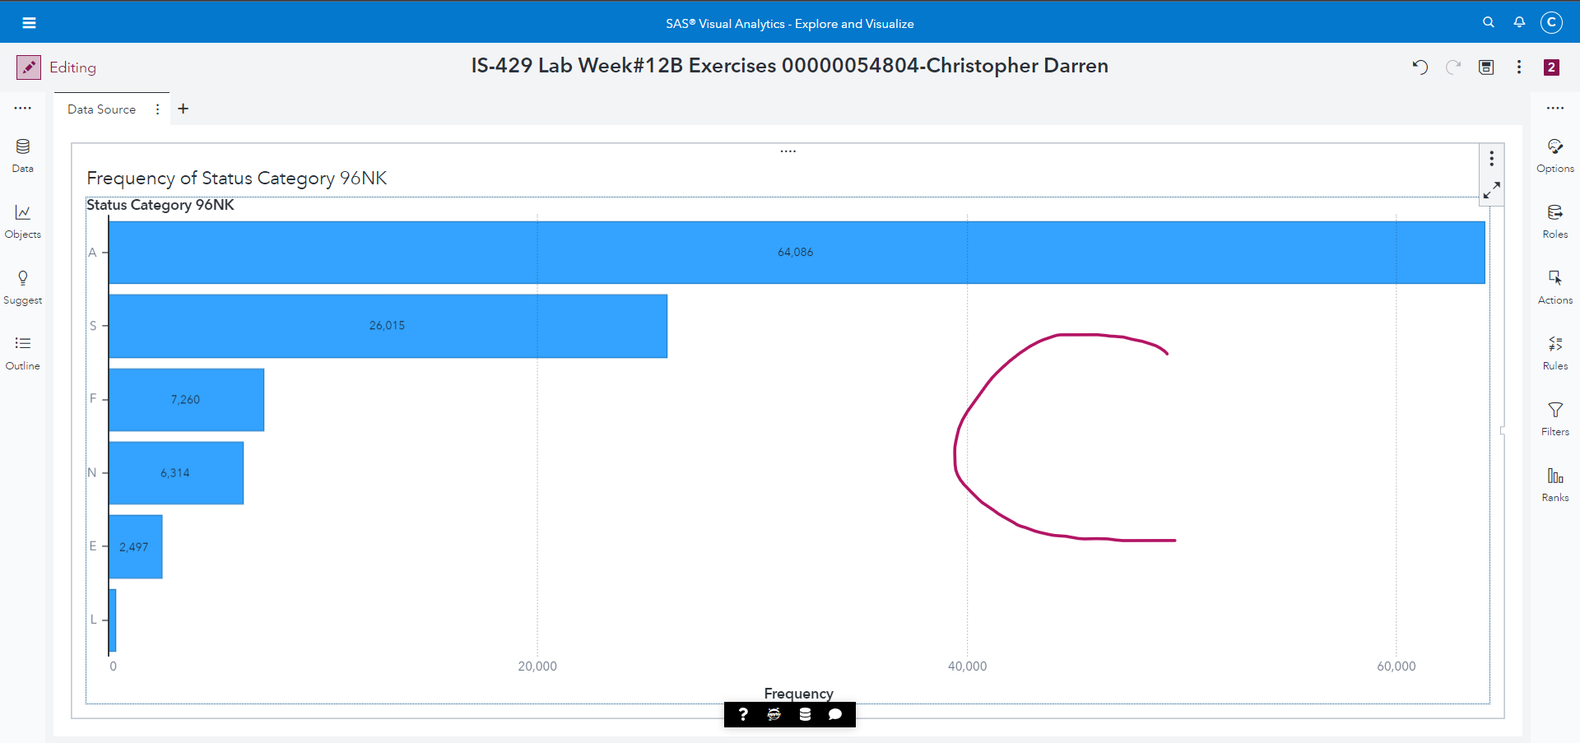

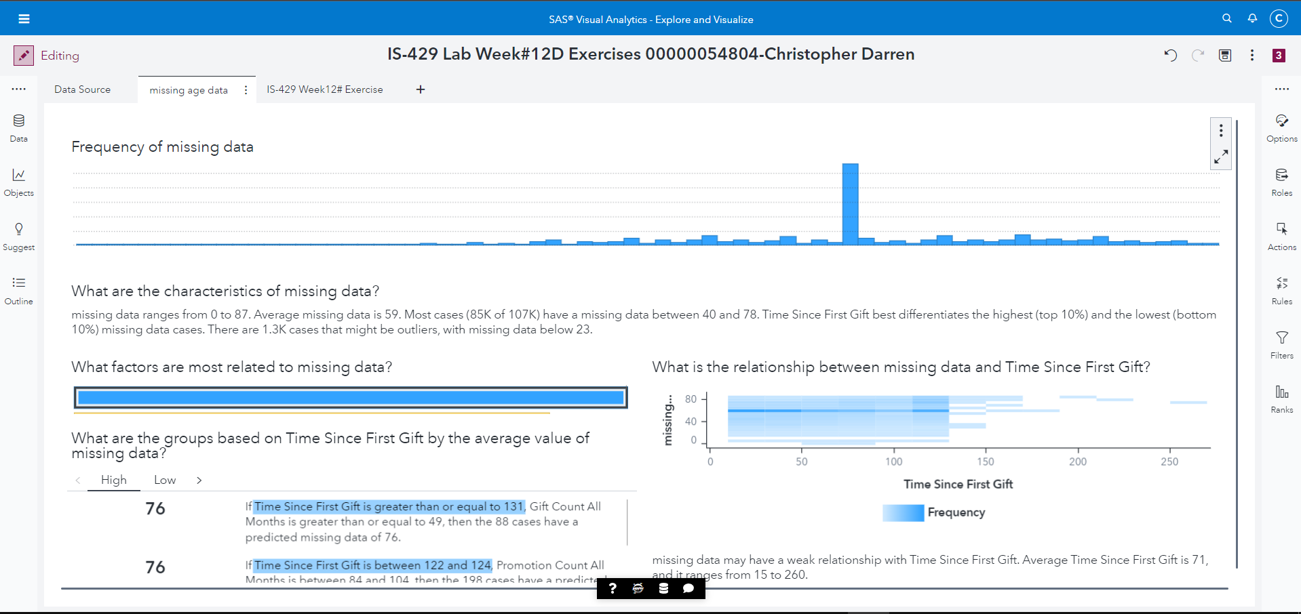

**Figure C.**

**Select the Data pane on the left of the canvas (if it is not open) and answer below questions:**

**1) Which level of the Status Category 96NK variable has the highest count? A**

**2) Does the variable Age contain any missing values? Yes**

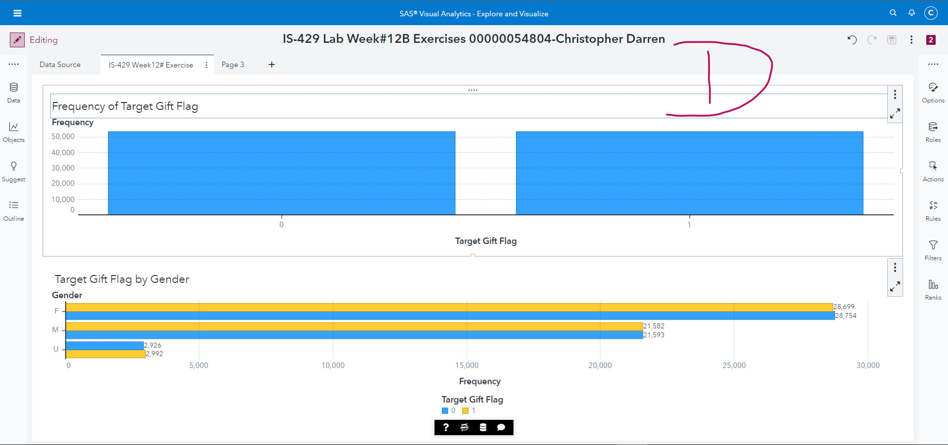

**Figure D.**

**Answer these below questions:**

**1) How are responders and non-responders distributed in the data?** Responders dan non responder terbagi rata dengan frekuensi 53,273

**2) How many females responded to the campaign?** 28,699 responds